**MONGO DB NOTES**

**Connecting to mongodb –**

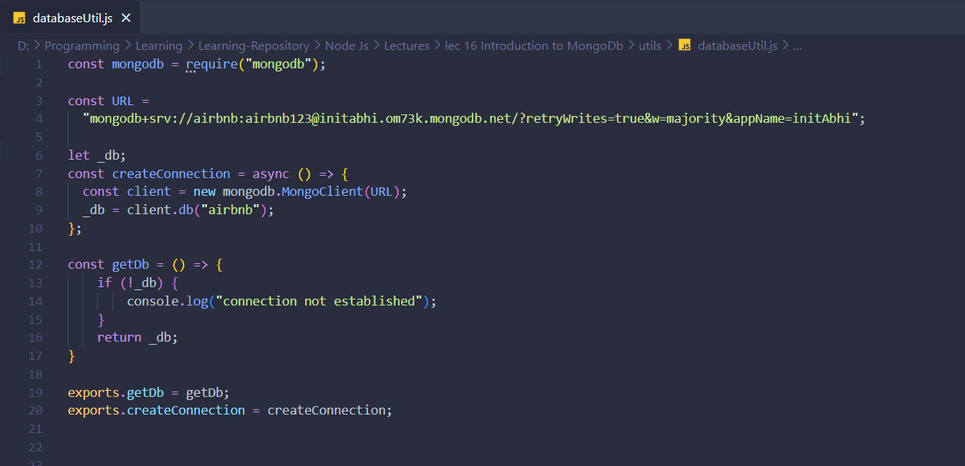

**How to use connection -**

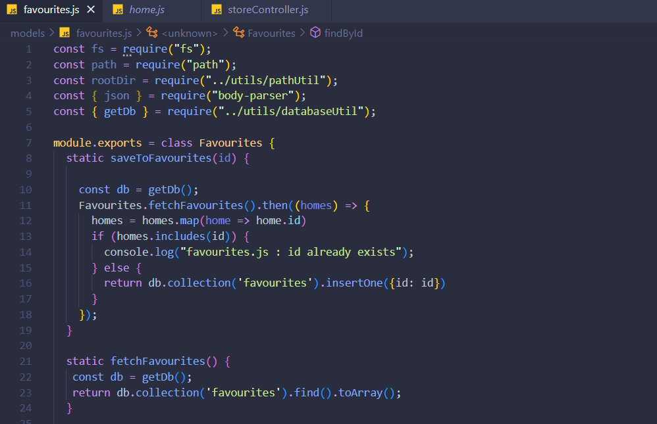

**Mongodb CRUD Methods –**

1. **Insert**
2. **Insertone -**

db.collection('favourites').insertOne({ id: 1, name: 'Item 1' });

1. **Insertmany –**

db.collection('favourites').insertMany([

{ id: 2, name: 'Item 2' },

{ id: 3, name: 'Item 3' },

]);